Support over Christmas and New Year

The festive period isn’t always festive for everyone. It can be a difficult time for some.
Whatever the issue and whatever is going on, it’s #OK2ASK for help.

Urgent support: if you are having thoughts of suicide, are harming yourself or have thoughts about self-harm, it's important to tell someone. These thoughts and feelings can be complex, frightening, and confusing, but you do not have to struggle alone. You can speak to your GP. If you cannot wait to see a doctor and feel unable to cope or keep yourself safe, contact Mersey care Mental Health Crisis Line 24/7 freephone on 0800 051 1508

You can also contact any of the services listed in this document.
NHS 24
24/7 freephone – 111 Choose option 2
For all ages – children, young people, and adults. If you need urgent mental health support, please call the free 24/7 helpline.

Samaritans
116 123
Whatever you're going through, a Samaritan will face it with you. We're here 24 hours a day, 365 days a year. Talk to someone 24/7

PAPYRUS/HOPELINE247
0800 068 41 41
For children and young people (under the age of 35)
or anyone concerned about a young person. Available 24/7 throughout Festive period.

Shout
Text SHOUT to 85258 - 24/7 text support.
A free and confidential messaging support service for anyone who is struggling to cope.
Available through Festive Period.

Amparo
0330 088 9255
Amparo provides emotional and practical support for anyone who has felt the impact of suicide.

Ok to Ask Suicide Prevention Campaign
www.oktoaskcampaign.co.uk
Lifelines, resources, and help. The campaign encourages St Helens residents to NOT be afraid to talk about Suicide Prevention

Talking Therapies https://www.merseycare.nhs.uk/our-services/st-helens/talking-therapies offer free NHS therapy for people registered with a St Helens GP with common mental health problems. Closed Bank Holidays.
Mersey Care Children and Adolescent 24/7 Mental Health Crisis Response Team Available 24/7 freephone- 01744 415 640 This service is available for children and young people up to the age of 18.

St Helens Wellbeing Service
https://www.sthelenswellbeing.org.uk/services/mental-wellbeing
Mental Health and Suicide Prevention Training.

Stay Alive App
https://www.stayalive.app/
An essential suicide prevention resource for the UK, packed full of useful information and tools to help people stay safe in crisis.

Service | Description and Contact Details | Opening Hours (from Monday 16th December 2024 – Thursday 2nd January 2025)
St Helens Wellbeing Service | We deliver a range of training and campaigns to promote knowledge and awareness of mental health, offering ways to improve mental wellbeing, and reducing stigma by encouraging discussions.  01744 371111  chcp.sthelens@nhs.net  www.sthelenswellbeing.org.uk  Infant Feeding Service:  07919 305 174 | 16th – 20th Dec – Usual service provision  25th, 26th Dec & 1st Jan – Service closed.  23rd, 24th, 27th, 30th and 31st December - Wellbeing Frontline service open 9 am – 5pm for phone calls, support and emails.  Infant Feeding Service:  23rd - 24th 8am-8pm  CLOSED Christmas Day  26th 10am-4pm  27th 8am-8pm  28th and 29th 10-4  30th 8am – 8pm  31st 8am – 8pm  CLOSED New Years Day with normal service resuming on 2nd January  Infant Feeding Support Groups  24/12 9.30am - 10.30am - Support Group Sutton family Hub  27/12 9.30am - 11am - Drop in Central Link Children’s Centre  Infant Feeding Clinic  30/12 1-1 Clinic (has to be booked) Lowe House Health Centre
KOOTH/QWELL | Free instant access digital mental health support is available across St Helens for everyone aged 11+. These services provide free, safe and anonymous online mental health support whenever you need it.  There are no waiting lists for support and no referral needed. Access to these platforms is available instantly 24/7.  Go to Kooth.com (11-25) or Qwell.io (18+) to get started today.  Support available includes:  - Live chat or messaging with qualified mental health professionals  - Self help tools and activities  - Online community  For enquiries about the service, get in touch via contact@kooth.com  For promotion or signposting support, contact kel@kooth.com | Kooth and Qwell platforms are available as below.  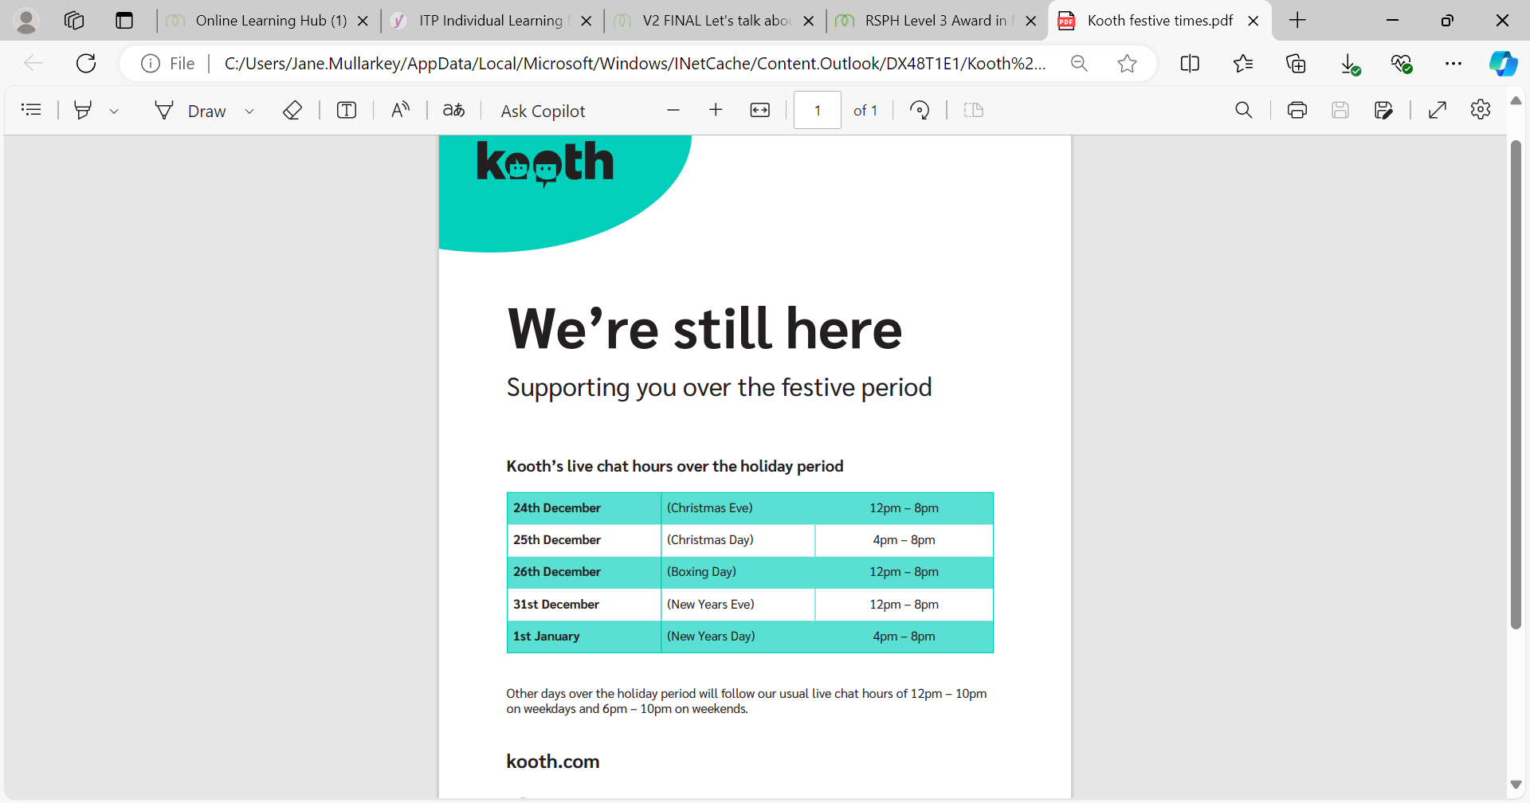  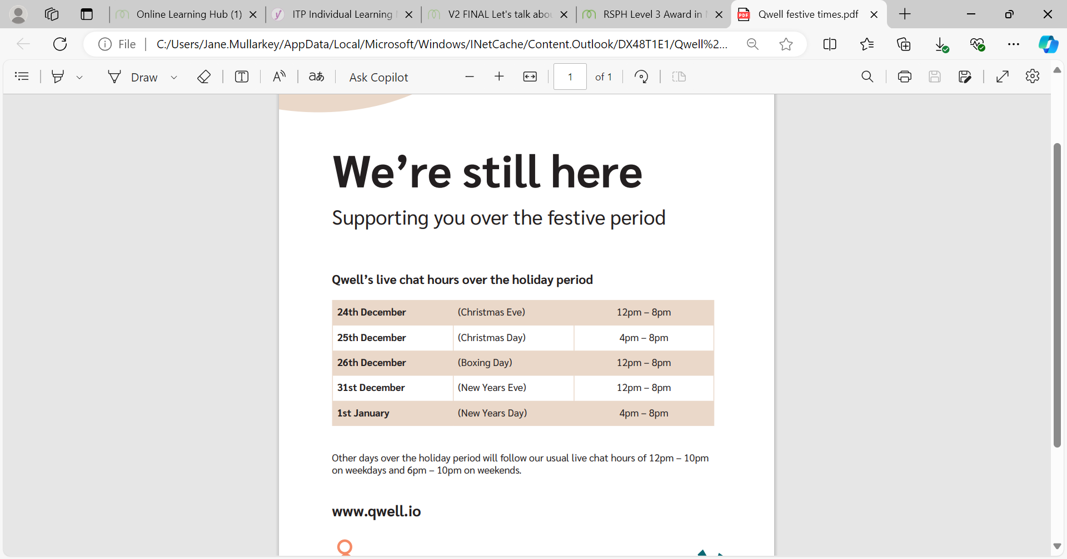
Creative Alternatives | Creative Alternatives (CA) is the Arts and Wellbeing Service for adult residents of  St Helens who are experiencing mild to moderate anxiety, depression &/or stress. CA offer free weekly creative sessions as a complimentary or alternative remedy that can help to improve your mental wellbeing, confidence, and social connections. All sessions currently take place in St Helens Town Hall.  For further information and details of how to refer please contact:  Helen Holden, Programme Manager  Email: helen@creativealternatives.org.uk  Tel: 07745 590698  Steph Fry, Support Worker  Email: stpehanie@creativealternatives.org.uk  Tel: 07594 677296  Or visit - www.creativealternatives.org.uk | CA regular group sessions stop during this period. However, we will still be accepting new referrals for either a January or February start, so can begin the referral process and add names onto the waiting list.  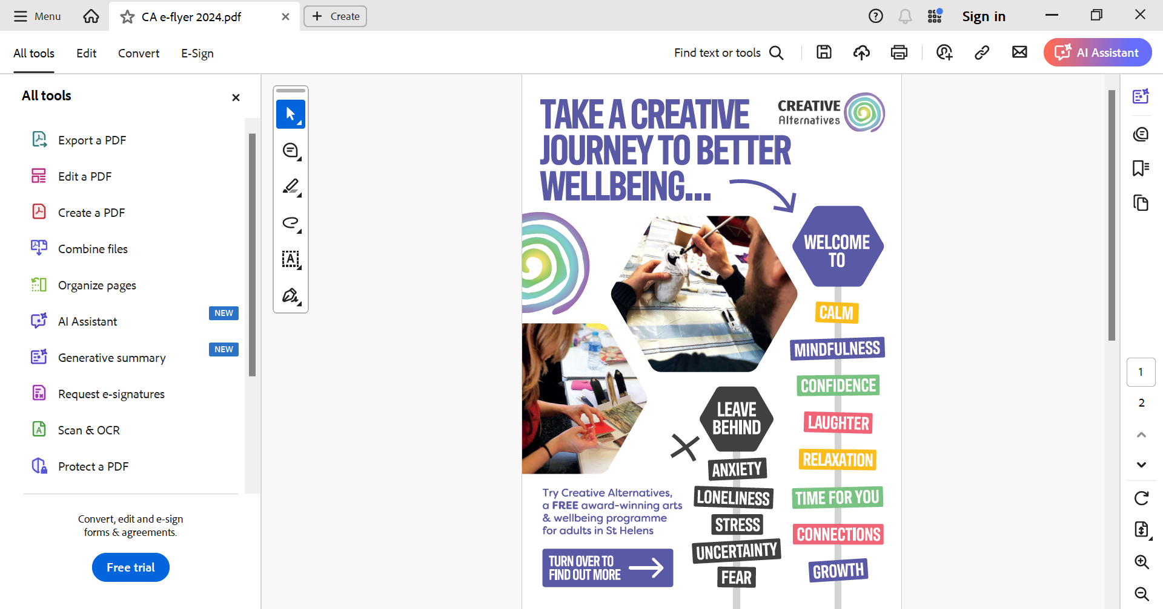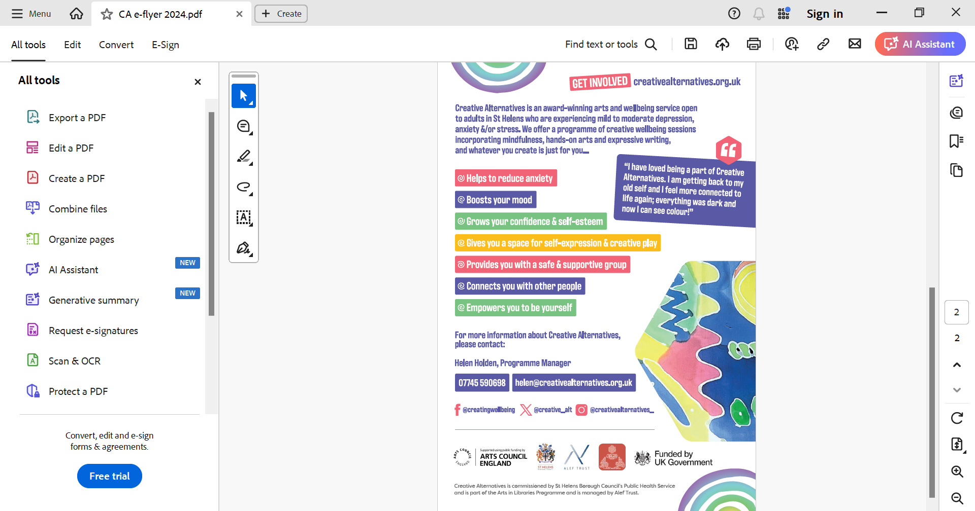
SOBs  Survivors of Bereavement by Suicide | We are the only UK-based organisation offering peer-led support to adults impacted by suicide loss. We help individuals support each other, at the time of their loss and in the months and years that follow. We aim to provide safe, confidential environments where people can share their experiences and feelings, giving and gaining support from each other.  Survivors of Bereavement by Suicide – Overcoming the isolation of people bereaved by suicide (uksobs.org) | Nationally, the email support will run over Christmas & New Year & the Helpline will be open Monday to Thursday 9:00am to 7:00pm.  St.Helens SoBs will close on 24th December at Lunch time through to 2nd January.  0300 111 5065 – Helpline  Other Support
Amparo & Listening ear | Emotional & practical support following a suicide, from day 1.  Counselling services.  CONTACT YOU  (PHONE/EMAIL/WEBSITE/LOCATION)  https://amparo.org.uk/refer/  0330 088 9255  https://listening-ear.co.uk/refer/  01514886648 | 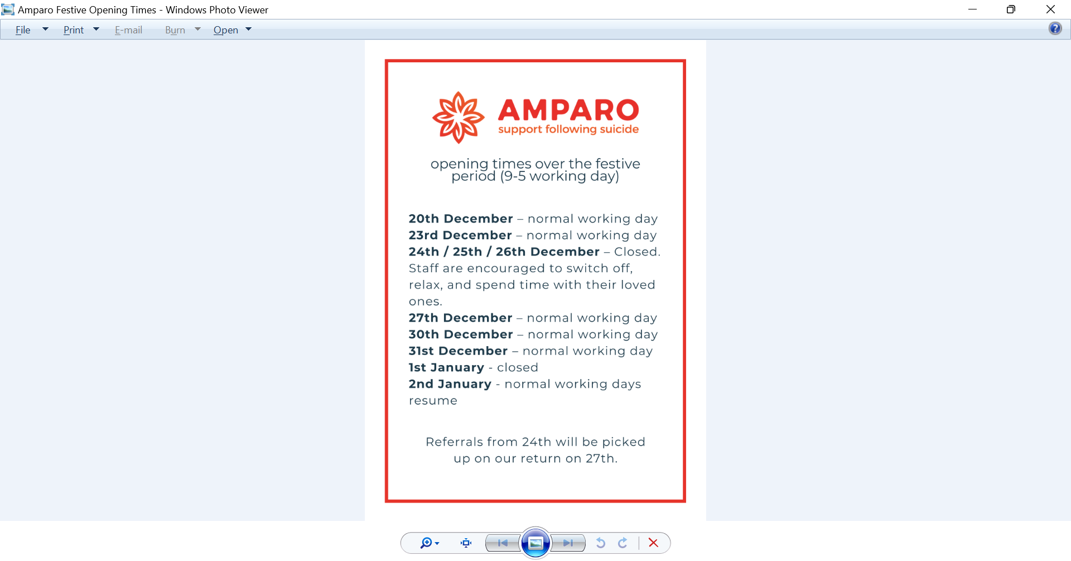
Hope House | Hope House is a drop-in service which also is providing Christmas holiday provision. It provides a basic needs and personal care service for local homeless and those at risk of homelessness and offers advice, advocacy, and support to support those in need. On Christmas Day, A Christmas Breakfast and Dinner will be available to those who will be accessing the service.  Contact Number:  01744 20032  E-Mail Address: Julie.hand@hopecentre.org.uk  Location:  41-43 Corporation Street  St.Helens  WA10 1ED | Monday 23rd December 2024 – 9:00am-15:30pm  Tuesday 24th December 2024 – 9:00am-13:00pm  Wednesday 25th December 2024 – 9:00am-14:00pm  Thursday 26th December 2024 – 9:00am-12:00pm  Friday 27th December 2024 – 9:00am-12:00pm  Saturday 28th December 2024 – CLOSED  Sunday 29th December 2024 – CLOSED  Monday 30th December 2024 – 9:00am-12:00pm  Tuesday 31st December 2024 – 9:00am-12:00pm  Wednesday 1st January 2025 – CLOSED  Thursday 2nd January 2025 – 9:00am-15:30pm  The last foodbank available for the Christmas period will be on:  Tuesday 24th December 2024 – Atherton Street (CLC). 11am-14:30pm  Foodbank will re-open on:  Thursday 2nd January 2025 –  Parish Church Hall - 11am-14:00pm  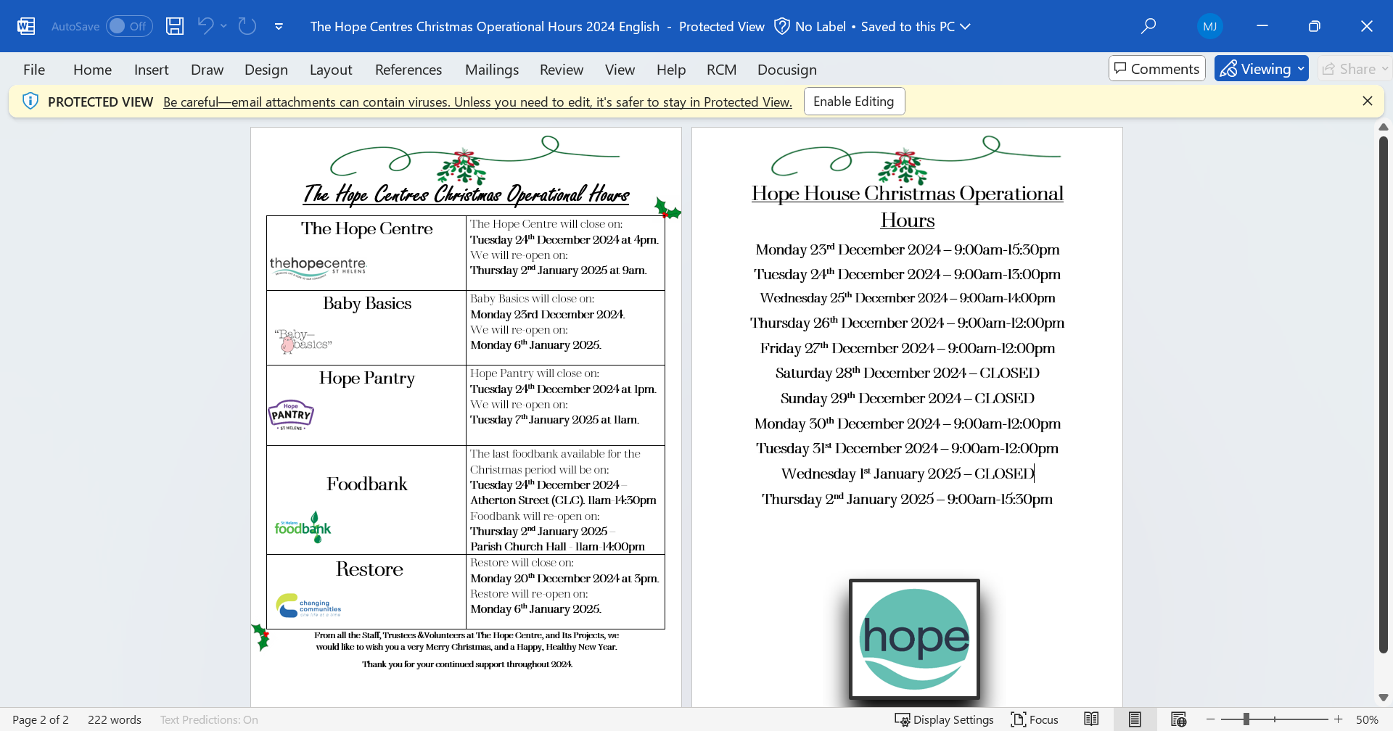
PAPYRUS Prevention of Young Suicide | HOPELINE247  HOPELINE247 is a confidential support and advice service for children and young people under the age of 35 who are experiencing thoughts of suicide, or anyone concerned that a young person could be thinking about suicide.  Call: 0800 068 4141  Text: 07860 039 967  Email: pat@papyrus-uk.org  Opening Hours  24 Hours, 7 days a week  Weekends and Bank Holidays included | If you are having thoughts of suicide or are concerned for a young person who might be you can contact HOPELINE247 for confidential support and practical advice.  Open throughout Festive period.
St Helens Talking Therapies (NHS Talking therapies Service) | Primary care support for common mental health problems. We will be offering initial assessments and ongoing therapy for clients with common mental health problems,  For Crisis support we recommend contacting  St Helens crisis numbers.  Talking Therapies :: Mersey Care NHS Foundation Trust | The service will be closed Christmas day, Boxing day and New Years Day.  Open as usual on the following dates, 9-5:  Monday 23rd, Tuesday 24th, Friday 27th, Monday 30th, Tuesday 31st December  From Thursday 2nd business as usual.
St Helens Bereavement Services Team | Information on Bereavement support and other support services, information about the Cemeteries and Crematorium over the holiday period.  Visit the Crematorium Office, St Helens Crematorium, Rainford Road, St Helens, WA10 6DF  Telephone: 01744 675490  https://citizen.sthel1-prd.gosshosted.com/media/9586/Bereavement-Support-Document-OCT-24/pdf/2400266_St_Helens_Bereavement_Document_October_2024_2.pdf?m=1729679020273 | Monday 16/12/24 – Friday 20/12/24  8.45am till 4.30pm  Monday 23/12/24 – Tuesday 24/12/24  8.45am till 4.30pm  Closed Christmas Day and Boxing day.  Friday 27/12/24, Monday 30/12/24 and Tuesday 31/12/24  8.45am till 4.30pm  Open as usual from 2nd January 2025.
Healthwatch St Helens | Healthwatch is the local watchdog around health & social care services, designed to collect local residents’ experiences and represent their views.  Contact: 0300 111 0007  Email: info@healthwatchsthelens.co.uk  Website: https://www.healthwatchsthelens.co.uk/
HOME-START ST HELENS | Family Support/School Readiness/Young Persons Mentoring & Sleep Management. Have a chat with a member of our team on 01744 737400 to discuss our support services.  Do you feel you would benefit from a volunteer’s home visiting supporting for you and your family?  Volunteers can provide emotional and practical support having life and lived experiences that are matched to your needs.  Alternatively, volunteers provide play sessions in your home that encourage your child’s development, supporting them to become school ready for life’s next chapter.  info@homestartsthelens.org.uk  https://homestartsthelens.org.uk/ | CLOSED FROM FRIDAY 20th DECEMBER 2024 – OPENS Thursday 2ND JANUARY 2025
Change Grow Live (CGL) | Adult substance misuse service providing treatment, interventions and support for individuals effected by substance use.  Contact Details:  Tel: 01744 410752  Email: sthelens.info@cgl.org.uk  Address: CGL  Lincoln House  80 Corporation Street  St Helens  WA10 6LE  Website:  www.changegrowlive.org/integrated-recovery-service-st-helens/drugs-support | Monday 16th December- 09:00- 17:00  Tuesday 17th December -09:00- 17:00  Wednesday 18th December- 09:00- 19:30  Thursday 19th December- 09:00- 17:00  Friday 20th December -09:00- 16:00  Saturday 21st December -09:00- 13:00  Monday 23rd December – 0900-1700  Tuesday 24th December – 0900-1700  Wednesday 25th December – Closed  Thursday 26th December – Closed  Friday 27th December – 09:00- 16:00  Saturday 28th December – 09:00- 13:00  Monday 30th December – 0900-1700  Tuesday 31st January – 900-1700  Wednesday 1st January – Closed  Thursday 2nd January – 900-1700
St. Helens Council Library Service | For the public library service, the public will be able to access St Helens Library, Newton-le-Willows Library and Schools Library Service during Christmas week as normal.  Contact is via the Council switchboard: 01744676789 | 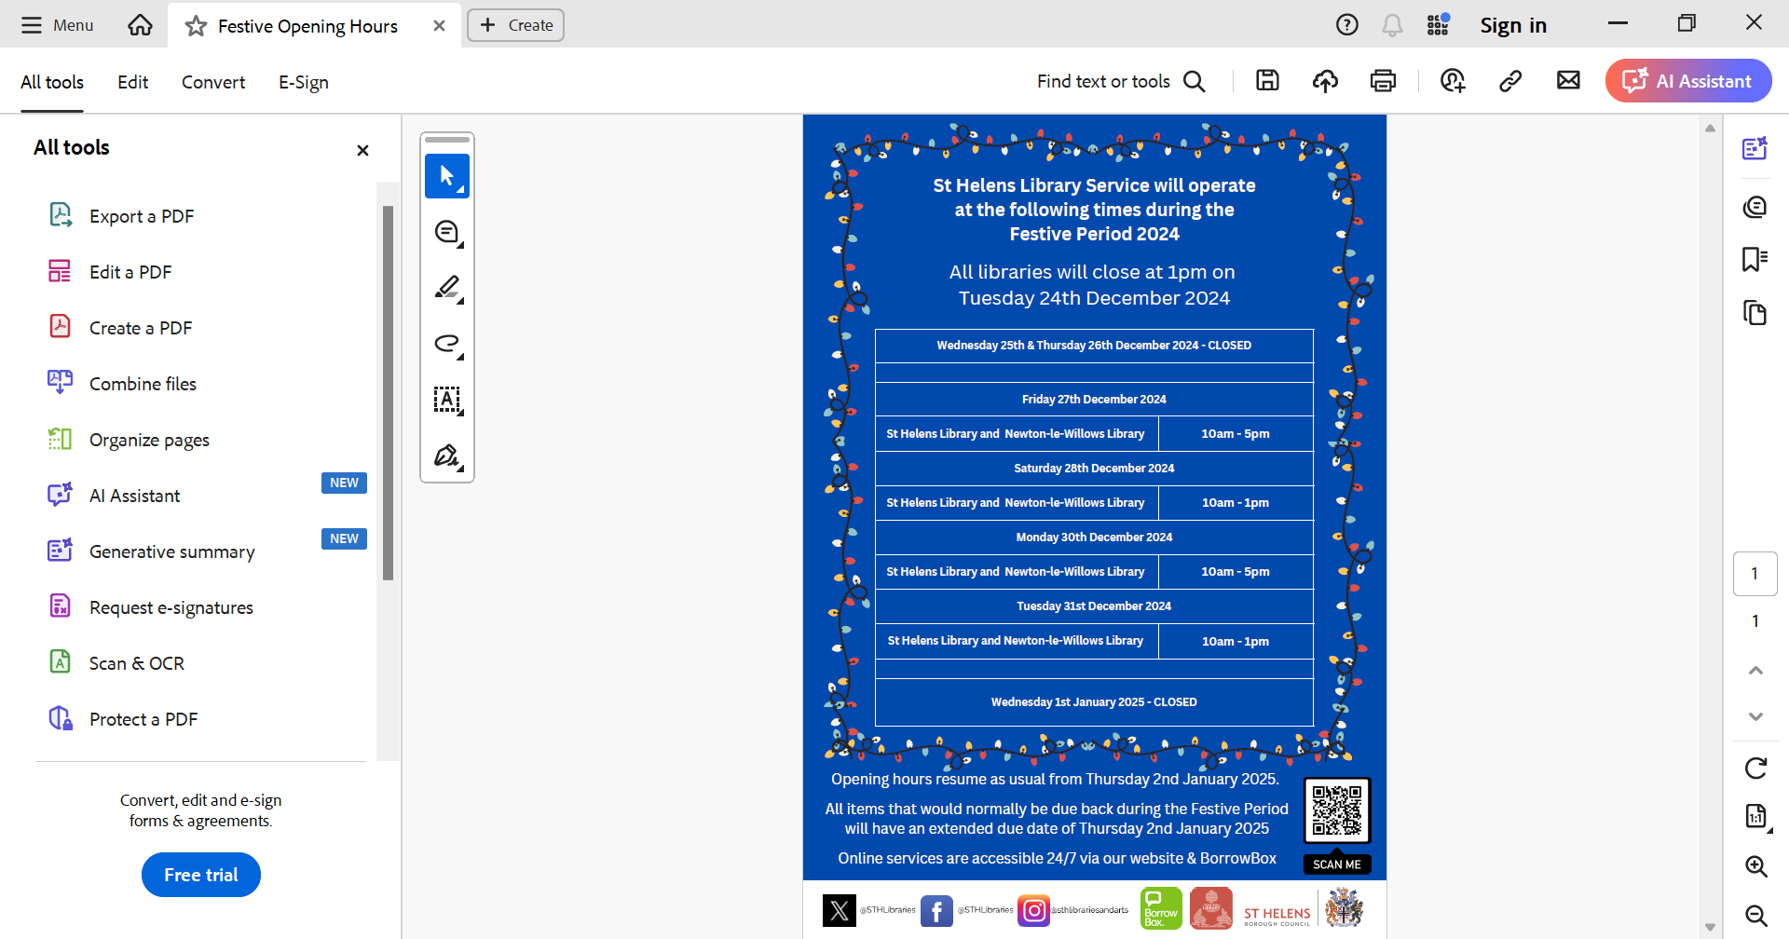
St Helens Council Arts in Library Service | Our mission is to provide diverse creative opportunities for audiences and participants within library spaces, online and in the community; to collaborate with artists and communities for the mutual benefit of all, and to share best practice with other library services across England.  Contact if urgent is via Arts Service email ArtsService@sthelens.gov.uk | Will be closed from Friday 20th December 4pm to January 2nd 9.00am.
YPDAAT | St Helens Young People's Drug and Alcohol Team (YPDAAT), provide young people and their families in St Helens with a range of interventions to help them to make informed choices around drug and alcohol use in order to achieve their full potential.  Normal business operating as usual.  Telephone 01744 675605 or email ypdaat@sthelens.gov.uk
St. Helens College | St. Helens College  Home (sthelens.ac.uk) | Closed from 20 December 2024 and will reopen on 07 January 2024
DWP  Department for Work and Pensions | Via Journal message or drop in at Job Centre  Gregson House, 2 Central St, Saint Helens WA10 1UF  Phone: 0800 169 0190  Department for Work and Pensions - GOV.UK (www.gov.uk) | 16th – 20th, 23rd and 24th Business as usual  25th -27th closed  1st Jan Closed  2nd onwards business as usual
HOUSING OPTIONS  (Will need to go via Contact Centre) | Contact Centre St.Helens Council  01744 676789  St Helens Borough Council - St Helens Borough Council | Closed Christmas Day, Boxing Day and New Years Day  23rd, 24th, 27th December 10am – 4pm
Domestic Abuse Helpline & IDVA services  01925 220541 (24 hour)  01744 743200 (M-F 9-5) | Safe2Speak | Support from the St Helens Domestic Abuse Team  Support for anyone dealing with Domestic Abuse and Violence | Closed Christmas Day, Boxing Day and New Years
Age UK Mid Mersey  01744 454530 | Welcome to Age UK Mid Mersey | Close on 24th December at 4pm and reopen on 2/1/2025 1pm.
Chrysalis centre  01744 451309 | Chrysalis Centre - Support for females | Closed from Friday 20th December and reopen on Monday 6th of January.
CAB  01744 737866 | Citizens Advice St Helens | Closed Friday 20th December. Reopen on Thursday 2nd January.  Direct to website for support during this time.
St Helens Contact Cares  01744 676767  contactcares@sthelens.gov.uk | 01744 676767 or by emailing  contactcares@sthelens.gov.uk  Contact Cares - St Helens Borough Council | Open 8am – 10pm throughout Christmas Period for all social Care and Adult Health refs in St.Helens.  contactcares@sthelens.gov.uk
St Helens Contact Centre | Contact Centre - St Helens Borough Council | Closed Christmas Day, Boxing day and New Years Day

Food Bank Requires Voucher
St John’s Foodbank, St.John Street, Earlestown, WA12 9DG | Wednesday 11:30-13:30  11th December  18th December  Closed until 8th January 2025
The Mount,  Parr Mount, Traverse Street, Fingerpost, WA9 1BW  01744 634980 | Monday 12:30-14:30  16th December  Closed until 6th January 2025
Newton CC  Park Road South  Newton-le-Willows  WA12 8EX | Friday 13th December 1.30am – 2.30pm:  Last day Newton Community Centre Food Bank is open  Re-opens on Friday 10th January 2025
St Helens Christian Life Centre & St Helens Parish Church Hall  Atherton Street  St Helens  WA10 2DT | Tuesday 24th December 2024 – Atherton Street (CLC). 11am-14:30pm  Foodbank will re-open on:  Thursday 2nd January 2025 –  Parish Church Hall - 11am-14:00pm
WA12 Food Share | £5.00 for annual membership then £1 per visit  They are based at 1A Haydock Street, Earlestown, WA12 9AB and are usually open:  Mondays – Fridays 10.30am -12.30pm and 9.15pm-9.45/10.00pm  Saturdays 9.00pm -10.00pm.  Sundays 5.00pm-6.00pm  Please note they have no spaces currently for new members but may still be able to help you with an emergency food parcel.  Please also note Foodshare is closed on Christmas Day and New Years Day  They can be contacted via their Facebook Group online which you can find by searching WA12 Domestic Abuse Food Share. They post updates of when their open on the page.
Food Pantries - £5 Weekly Subscription
St Marks Haydock – Only support Haydock and Blackbrook | Monday 16th 17:30-19:00  Thursday 19th 9-11  Close for two weeks and reopen on 6th January
St Lukes | Wednesday 18th December 15:00-17:00  Close for 2 weeks and reopen on 8th January
St Matthews Thatto Heath | Monday 16th 18:30-20:00  Wednesday 18th 10am-12 noon  Close for 2 weeks and reopen 6th January
Hope @ the Wesley Church | Last day 24th December and reopen 7th January 2025
Cornerstone
Lester Drive Centre
St Helens
WA10 5BF

St Helens Mobile Pantry | Open on 23rd and 24th Closed until 6th January 2024
Cross Lane United Church, Newton Le Willows , 10:30-12:00 | 23rd December
Sutton Family Hib, Ellamsbridge Road 10:30-12 | 24th December

